**OFFLINE AI CHATBOT USING AWS & DevOps**

*Prepared in the partial fulfillment of the Summer Internship Program on AWS*

AT

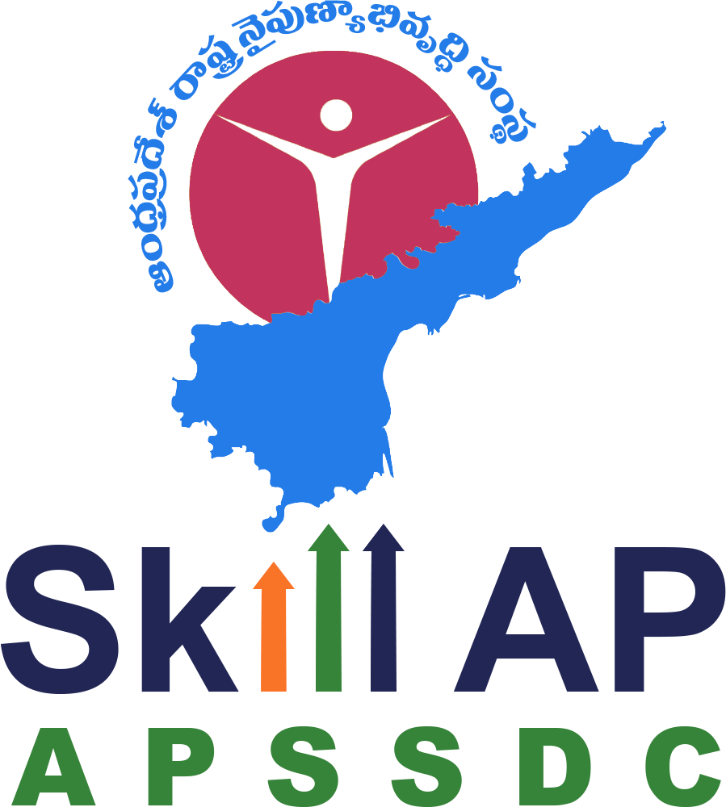

*Under the guidance of*

### Mrs. Sumana Bethala, APSSDC Mr. Anil Kumar, APSSDC

*Submitted by*

*The Project Team (Batch number- 39)*

***Botsa Gowthami (23MH1A05F1)***

***Konthala Yashwanth Reddy (23MH1A05M5)***

***Nuthalapathi Harthika (23MH1A0545)***

***Dulipalla Radhika (23MH1A0587)***

***K Shravani (23MH1A42E8)***

*ADITYA COLLEGE OF ENGINEERING AND TECHNOLOGY*

*SURAMPALEM (A.P)*

# ACKNOWLEDGEMENT

We would like to express our heartfelt gratitude to all those who have contributed to the successful completion of our project titled **“Offline AI Chatbot using AWS Cloud Computing and DevOps.”** This project has been an incredibly valuable learning experience, and we are truly thankful for the guidance, support, and encouragement received throughout this journey.

First and foremost, we extend our sincere thanks to **[Your Mentor's Name / Internship Guide]** for their constant guidance and mentorship. Their insights and feedback played a crucial role in shaping the direction of this project and helping us overcome challenges during the development process.

We are deeply grateful to the **Andhra Pradesh Skill Development Corporation (APSSDC)** for providing us with this opportunity to explore cutting-edge technologies in cloud computing and artificial intelligence. The internship framework enabled us to apply our technical knowledge in a real-world context.

We would also like to thank each member of our team for their collaborative spirit, dedication, and technical contributions. Every individual brought unique strengths to the table, and our collective effort led to the successful execution of this project.

Lastly, we extend our appreciation to our families and friends for their continuous encouragement and support during this internship.

We are proud to have completed this project as part of our summer internship, and we look forward to utilizing the skills and experiences gained in future endeavors.

**Sincerely,**  
The Project Team (Batch number- 39)  
*Offline AI Chatbot using AWS & DevOps*

# ABSTRACT

The **Offline AI Chatbot using AWS Cloud Computing and DevOps** is a cutting-edge project designed to create a smart conversational assistant that can operate in offline environments, with the ability to synchronize data and models using cloud infrastructure. This project focuses on delivering intelligent chatbot capabilities without relying on continuous internet connectivity, making it ideal for remote or bandwidth-limited regions.

The chatbot leverages lightweight Natural Language Processing (NLP) models capable of running locally while providing meaningful interactions with users. The system architecture integrates **Amazon Web Services (AWS)** for model storage (S3), compute resources (EC2), and CI/CD automation (CodePipeline), enabling seamless updates and scalability when connected online.

By combining offline AI functionality with cloud-native tools and DevOps pipelines, the project demonstrates a powerful blend of reliability, performance, and automation. Key components include local model inference using pre-trained transformers, a Dockerized deployment approach for portability, and an optional frontend (CLI or web-based) for user interaction.

This report outlines the system design, implementation methodology, and technical decisions involved in developing the offline AI chatbot. It also highlights the collaborative effort of the team and the strategic use of AWS services to build a modern, scalable, and resilient AI solution. The project stands as a practical demonstration of how artificial intelligence and cloud computing can be unified to create impactful, real-world applications.

# TABLE OF CONTENTS

| **S.No** | **Content** | **Pg. No.** |
| --- | --- | --- |
| 1 | Acknowledgement | 2 |
| 2 | Abstract | 3 |
| 3 | Table of Contents | 4 |
| 4 | Introduction | 5-6 |
| 5 | Methodology | 7-8 |
| 6 | System Design / Architecture | 9-11 |
| 7 | Implementation | 12-14 |
| 8 | Results | 15-16 |
| 9 | Conclusion | 17-18 |

1. **INTRODUCTION**

In today’s fast-evolving digital landscape, artificial intelligence and cloud computing have become cornerstones of modern technology. From personalized assistants to automated business systems, AI-powered solutions are increasingly becoming integral to how individuals and organizations interact with technology. However, many AI-driven applications, particularly chatbots, rely on continuous internet connectivity to function — making them inaccessible in rural or offline environments.

The **Offline AI Chatbot using AWS Cloud Computing and DevOps** is an innovative solution to this challenge. The project was conceptualized with the goal of developing an intelligent chatbot that can operate efficiently without internet access while leveraging cloud infrastructure for updates, deployment, and automation. It is specifically designed for users in regions with limited or intermittent internet connectivity, enabling them to access AI-driven assistance offline.

At the core of this project lies a lightweight NLP (Natural Language Processing) model, such as **DistilBERT**, that runs locally and generates intelligent responses based on user input. The chatbot is trained to handle a wide range of common queries and conversations while storing all necessary data on the local machine. To keep the system scalable and maintainable, the chatbot is packaged in a **Docker container**, making it portable and consistent across various environments.

The integration with **Amazon Web Services (AWS)** plays a vital role in managing model updates and deployment workflows. By using services like **Amazon S3**, **EC2**, **IAM**, and **CodePipeline**, the project incorporates cloud synchronization for fetching the latest model versions and automates the deployment process via CI/CD pipelines. This hybrid offline-online architecture ensures that the chatbot stays up-to-date when internet access is available while continuing to function seamlessly in offline mode.

Moreover, **DevOps practices** were incorporated to ensure a streamlined and automated build-deploy pipeline.

The team employed tools such as GitHub, CodePipeline, and CloudWatch for version control, continuous integration, and monitoring. This approach not only improves software reliability but also enhances collaboration within the development team.

This report provides a detailed overview of the planning, design, and implementation of the chatbot, including the architecture, methodologies adopted, technologies used, challenges encountered, and testing performed. The solution demonstrates how AI, cloud computing, and DevOps can be combined to build robust, scalable, and accessible systems — contributing to digital inclusivity for users in low-connectivity regions.

In summary, the **Offline AI Chatbot** is a practical and scalable system that bridges the digital divide, providing smart communication tools to users regardless of internet availability, powered by the flexibility and strength of AWS cloud infrastructure and DevOps workflows.

# METHODOLOGY

The development of the **Offline AI Chatbot using AWS Cloud Computing and DevOps** followed a structured and iterative methodology to ensure the successful delivery of each functional component. This methodology enabled the team to align technical development with project goals while allowing for continuous feedback, testing, and enhancement.

**5.1. Requirements Gathering**

The project began with collaborative discussions to understand the expectations of an offline AI chatbot and how AWS cloud services could be leveraged to enhance its functionality. Core features such as offline interaction, model synchronization from S3, and Docker-based deployment were finalized during this phase.

**5.2. Design**

A modular design was adopted with clear separation between components — AI model, frontend UI, cloud integration, and DevOps pipeline. Emphasis was placed on creating a chatbot that could run offline while still being connected to an update system via AWS. Flow diagrams and architecture were designed to visualize system flow and interactions.

**5.3. Implementation**

The chatbot logic was implemented in Python using lightweight NLP models (e.g., DistilBERT) that support local inference. The application logic was packaged inside a Docker container to ensure portability. The model and supporting files were hosted on an AWS S3 bucket for easy access and updates. A basic user interface was also created using either React.js or a command-line interface (CLI) for direct input/output.

**5.4. Cloud Integration**

An AWS S3 bucket was created to store the chatbot model and allow model synchronization. EC2 instances were used for remote testing and cloud deployment. IAM roles were configured to manage secure access to AWS services. AWS CLI and Python's boto3 library were used to interact with cloud resources from the application.

**5.5. DevOps & CI/CD**

To ensure fast, reliable, and automated deployments, AWS CodePipeline and CodeBuild were integrated with the GitHub repository. This setup allowed the chatbot to be automatically built and deployed whenever changes were pushed to the codebase. The Docker container was tested locally and on EC2 before final release.

**5.6. Testing**

Extensive local testing was performed to verify offline chatbot functionality. The model sync script was tested to ensure accurate retrieval of updated models from S3. CI/CD pipelines were tested with dummy commits to verify automatic deployments. Logs were monitored using AWS CloudWatch.

**5.7. Iterative Refinement**

Throughout the 7-day development process, feedback loops were established among team members. Continuous testing, small bug fixes, and UI/UX improvements were made. The final system was a result of collaborative iteration, balancing speed and quality.

# SYSTEM DESIGN / ARCHITECTURE

The **Offline AI Chatbot using AWS Cloud Computing and DevOps** is designed to operate locally while seamlessly integrating with AWS for synchronization, deployment, and automation. The architecture is modular and follows a three-tier model, comprising the **Presentation Layer**, **Application Logic Layer**, and **Data Management Layer**. It also includes DevOps and Cloud Hosting components for CI/CD and scalable deployment.

**6.1. Presentation Layer**

The presentation layer serves as the user interface of the chatbot system. It is designed to accept user inputs and display AI-generated responses in an intuitive format. The UI can be implemented using either a command-line interface (CLI) or a web interface built with React.js for better interaction.

**Key Features of the Presentation Layer:**

* Input/output interface for user messages and bot replies
* Console or web-based environment for user interaction
* Clean layout for response clarity and flow

**6.2. Application Logic Layer**

This layer functions as the core engine of the chatbot. It consists of Python-based logic that takes user input, processes it using an offline NLP model, and generates an appropriate response. The logic also handles error checking, fallback responses, and log saving.

**Core Components:**

* Local NLP model (e.g., DistilBERT or Rasa)
* Python scripts for inference and response generation
* Integration with the frontend for live interaction
* Logging mechanism for saving chats locally

**6.3. Data Management Layer (Cloud Sync)**

The data management layer is powered by AWS services — primarily **Amazon S3** — which is used to store and manage the chatbot model files. The application includes a sync script that pulls the latest model version from S3 whenever internet access is available.

**Features:**

* Secure access using IAM roles and AWS CLI
* Python-based script to fetch model from S3
* Local caching to ensure offline access after initial download

**6.4. DevOps Integration (CI/CD)**

To streamline deployments, AWS **CodePipeline** and **CodeBuild** are used to automatically build and deploy new chatbot versions. Whenever the code is pushed to GitHub, the CI/CD pipeline triggers a rebuild and redeployment process to the EC2 server.

**Features:**

* GitHub integrated with AWS CodePipeline
* buildspec.yml used to define pipeline stages
* Continuous Deployment using EC2 instances or S3 sync targets

**6.5. Cloud Hosting (EC2 Deployment)**

For remote or online use cases, the chatbot system is deployed on an **EC2 instance** with Docker installed. The EC2 acts as a cloud-based fallback when the local version is unavailable. It also serves as a centralized testing and logging server.

**Components:**

* Ubuntu EC2 instance with Docker and Python
* AWS Security Groups configured for SSH and HTTP
* Optionally runs a web version of the chatbot

This modular and hybrid architecture ensures that the chatbot can work both **offline and online**, making it robust, portable, and scalable. The use of AWS cloud services enhances flexibility and future growth potential.

# IMPLEMENTATION

The implementation phase of the **Offline AI Chatbot using AWS Cloud Computing and DevOps** focused on translating the designed architecture into a fully functional and interactive system. This section describes the development of each component — from frontend and backend to model integration, cloud configuration, and CI/CD automation.

**7.1. Frontend Development**

The frontend of the chatbot system was developed in two formats based on the user environment:

1. **Console-based CLI**, for quick and offline interaction.
2. **React-based Web Interface** (optional), offering a more user-friendly experience.

**Key Features:**

* Input and output fields to simulate a live chat
* Clean, readable display of messages
* Simple form submission and response handling
* Connected directly to the Python-based chatbot engine

**7.2. Backend Development**

The backend forms the core chatbot logic. It was developed using Python and utilizes pre-trained NLP models such as **DistilBERT** or **DialoGPT** from Hugging Face Transformers.

**Implementation Details:**

* Python script processes user input and generates a reply using the loaded model
* Error handling, fallback responses, and simple intent matching included
* Local chat logs saved in a .json or .txt format for offline usage
* Flask or CLI used to expose chatbot interface

**7.3. Model Hosting and Synchronization**

To ensure updatability, the chatbot model is stored on **Amazon S3**. A Python-based sync script using boto3 was developed to:

* Check for model updates in S3
* Download new model files to the local system
* Replace older versions for immediate offline access

IAM roles were configured to restrict access only to model-specific resources, ensuring secure cloud interaction.

**7.4. Dockerization**

The complete chatbot system was Dockerized to allow cross-platform portability. A Dockerfile was created with instructions to:

* Install dependencies
* Load the NLP model
* Start the chatbot interface (CLI or Flask app)

This allowed the chatbot to run uniformly across different environments, including local machines and AWS EC2 instances.

**7.5. CI/CD Pipeline Setup**

To automate the deployment process, **AWS CodePipeline** and **CodeBuild** were configured with GitHub integration. The pipeline was triggered on every code push and executed the following:

* Pulled latest code from GitHub
* Built and packaged the Docker image
* Deployed to EC2 or synced with S3
* Generated logs for deployment status

The pipeline setup ensured smooth development-to-deployment transitions and reduced manual errors.

**7.6. Cloud Hosting (EC2 Deployment)**

An **Amazon EC2 instance** running Ubuntu was used to host the chatbot remotely. After testing locally, the Docker image was deployed and run on EC2, allowing access to the chatbot in an online environment.

**Steps Followed:**

* EC2 instance setup with appropriate security groups
* SSH access used for deployment
* Docker and Python installed
* Chatbot container launched using Docker run commands

This implementation phase ensured that every component worked both independently and together as part of a larger system — meeting the requirements of **offline usability**, **cloud support**, and **DevOps automation**.

# RESULTS

The development and deployment of the **Offline AI Chatbot using AWS Cloud Computing and DevOps** successfully fulfilled the project's primary objectives. The system was tested across multiple scenarios to ensure functionality in offline mode, accuracy of chatbot responses, smooth cloud synchronization, and seamless DevOps-based automation. The outcomes of each module are summarized below:

**8.1. Functional Offline Chatbot**

The chatbot was successfully implemented using a pre-trained NLP model capable of running entirely offline. Users were able to interact with the chatbot through a command-line interface or optional web interface, receiving meaningful responses in real time without internet dependency.

**8.2. Cloud-Based Model Synchronization**

A Python script was created and tested to fetch the latest model from an AWS S3 bucket. When internet access was available, the chatbot could securely download updated model files and replace local versions, maintaining offline functionality with the latest data.

**8.3. Containerization with Docker**

The chatbot application was successfully packaged into a Docker container. This ensured cross-platform compatibility and allowed team members to run the bot locally without manual setup. The container included all required dependencies, making it fully portable and consistent across systems.

**8.4. CI/CD Pipeline Integration**

The GitHub repository was integrated with **AWS CodePipeline** and **AWS CodeBuild** to automate deployments. With every push to the main branch, a new pipeline run was triggered, fetching code, building the Docker image, and syncing it to S3 or deploying it to an EC2 instance. Logs were monitored using **AWS CloudWatch**.

**8.5. Cloud Deployment via EC2**

An EC2 instance running Ubuntu was provisioned to host the chatbot remotely. The Dockerized chatbot was deployed successfully, enabling access to the bot from the cloud environment. Security groups and IAM roles were configured to control access.

**8.6. Chat Logging and Local Storage**

All chatbot interactions were saved locally in structured .json log files, even during offline sessions. This allowed tracking of queries, troubleshooting, and later analysis of chatbot performance.

**8.7. Team Collaboration and Workflow Success**

Using a clear day-wise plan, the 5-member team effectively divided roles and completed all tasks within the 7-day timeline. The collaborative workflow ensured simultaneous progress on AI development, AWS setup, UI, and DevOps pipeline configuration.

1. **CONCLUSION**

The development of the **Offline AI Chatbot using AWS Cloud Computing and DevOps** has resulted in a robust, intelligent, and portable system capable of functioning effectively in both connected and offline environments. By integrating artificial intelligence with cloud services and automated deployment pipelines, the project successfully addresses the challenges faced in areas with limited or no internet access.

The chatbot, powered by lightweight NLP models such as DistilBERT, demonstrated the ability to deliver accurate and meaningful responses in offline mode. Cloud synchronization with AWS S3 ensured that model updates could be downloaded whenever internet access was restored, maintaining the system’s flexibility and adaptability.

The use of **Docker** enabled platform-independent deployment, while **AWS EC2** provided a stable environment for cloud hosting and testing. The addition of **AWS CodePipeline** allowed for CI/CD automation, enabling seamless updates from GitHub with minimal manual effort.

This project not only served as a technical implementation of modern AI and DevOps tools, but also as a collaborative learning experience for the team. Every member contributed to a specific layer of the architecture, from cloud infrastructure to AI logic and DevOps workflow, resulting in a successful end-to-end solution.

Looking forward, this system can be extended with additional features such as voice input, multilingual support, a web-based dashboard for admin control, and integration with external APIs. Its modular design and scalable architecture make it suitable for further development in both educational and enterprise settings.

In conclusion, the **Offline AI Chatbot** stands as a practical demonstration of how cloud computing, artificial intelligence, and DevOps can be unified to create impactful solutions for real-world problems — especially in environments with limited connectivity.